**Aggregate Functions MCQs**

**1.Observe the given SQL query and choose the correct option.**

**SELECT** branch_name, **COUNT** (**DISTINCT** customer_name)

**FROM** depositor, account

**WHERE** depositor.account_number = account.account_number

**GROUP** **BY** branch_id

a) The query is syntactically correct but gives the wrong answer

b) The query is syntactically wrong

c) The query is syntactically correct and gives the correct answer

d) The query contains one or more wrongly named clauses.

**2.We apply the aggregate function to a group of sets of attributes using the _______ clause**.

a) group by

b) group

c) group set

d) group attribute

**3.The _____ aggregation operation adds up all the values of the attribute**

a) add

b) avg

c) max

d) sum

**4. State true or false: Any attribute which is present in the having clause without being aggregated must not be present in the group by clause.**

a) True

b) False

**5. What values does the count(*) function ignore?**

a) Repetitive values

b) Null values

c) Characters

d) Integers

**Use the dataset sql_for_business_analytics.employees_1**

**1) Write a SQL query to fetch the departments in upper case , then show the number of departments.**

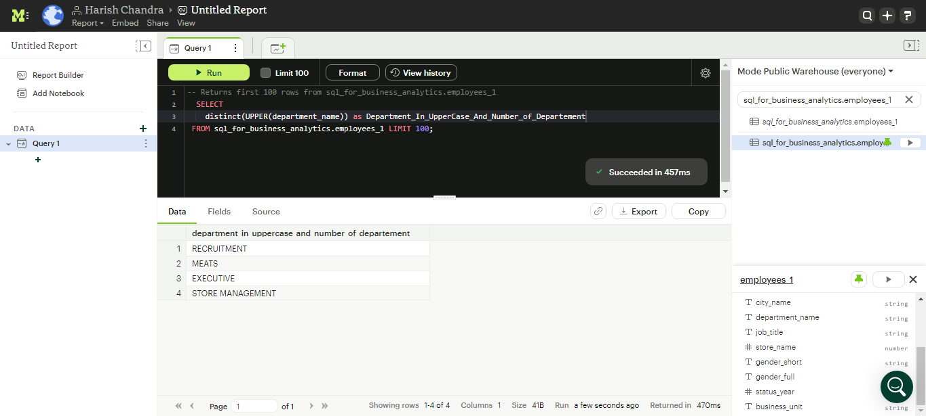

**SELECT**

**distinct(UPPER(department_name)) as Department_In_UpperCase_And_Number_of_Departement**

**FROM sql_for_business_analytics.employees_1 LIMIT 100;**

**2) Find the maximum service length**

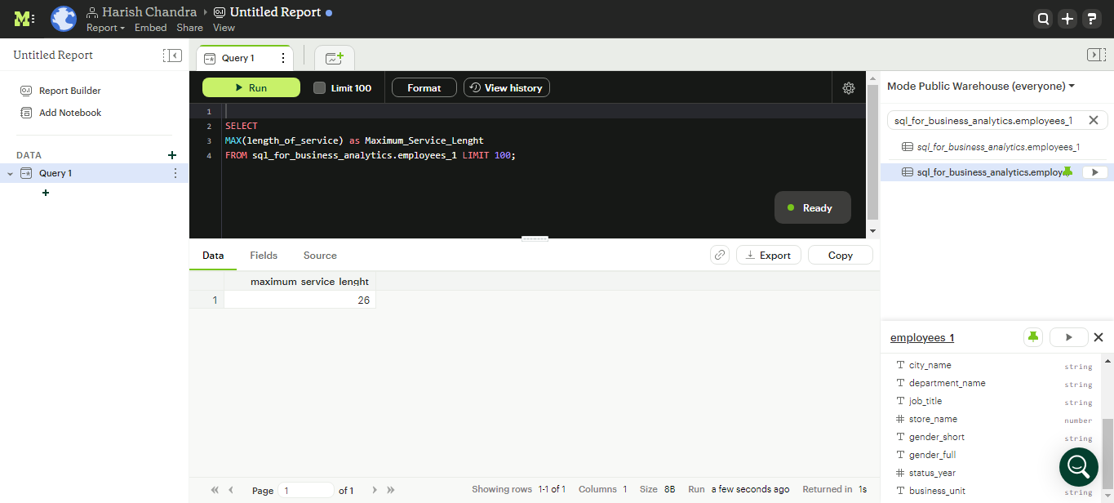

**SELECT**

**MAX(length_of_service) as Maximum_Service_Lenght**

**FROM sql_for_business_analytics.employees_1 LIMIT 100;**

**3) Find the number of employees belonging to each unique city.**

Select COUNT(DISTINCT (city_name, employee_id))

FROM **sql_for_business_analytics.employees_1;**

4) Find the minimum and maximum age at which an employee was terminated.

SELECT Year

MIN(age**) as minimum _age ,MAX(**age**) as maximum _age**

**FROM sql_for_business_analytics.employees_1**

**WHERE employee are ‘terminated’**

**GROUP BY year**

**ORDER BY YEAR**

5) Calculate the average service length and find those employees whose service length is

greater than average.

**Select**

**AVG(length_of_service)as avg**

**FROM sql_for_business_analytics.employee_1**

**GROUP BY employee_id**

**HAVING employee_id> avg(length_of_service);**